Manon Blaiteau

Bernal Institute – University of Limerick

With John MULVIHILL  
September 23 – January 24

research Project

Re-sterilization of metal coupons

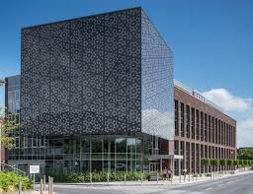

Table des matières

Introduction 2

1. My research project 3

1.1. Project description 3

1.2. Research 4

1.2.1. Sterilization methods used in hospitals 4

1.2.2. Side effects of re-sterilization 4

1.2.3. How to sterilized / re-sterilized a pacemaker (which is a single-used device) 4

1.2.4. Which method of sterilization corresponds for each material? 6

1.3. Methods 7

1.3.1. Protocols 7

1.3.2. Training with metal parts 7

1.3.3. Sterilization of coupons - Autoclave 10

1.3.3.1. Titanium coupons 10

1.3.3.2. Copper coupons 11

1.3.4. Sterilization of coupons - UV 12

1.3.4.1. Titanium coupons 12

1.3.4.2. Copper coupons 13

1.3.5. SEM method 14

Conclusion 15

Glossary 16

Annex 17

Annex 1: Reprocessing of CIED 17

Annex 2: Sterilization protocol of metal part by autoclave 18

Annex 3: Sterilization protocol for metal part by UV 19

Annex 4: Sterilization protocol for coupons by autoclave 20

Annex 5: Sterilization protocol n°1 for coupons by UV 21

Annex 6: Sterilization protocol n°2 for coupons by UV 22

Annex 7: Sterilization protocol n°3 for coupons by UV 23

Annex 8: Sterilization protocol n°4 for coupons by UV 24

Annex 9: Summary of all the autoclave experiments 25

Annex 10: Summary of all the UV experiment 25

# Introduction

I am currently in my fifth year at Icam Bretagne, a general engineering school located in Vannes. Since September 2021, I have been doing an apprenticeship at Panpharma, a pharmaceutical company. As part of my scholarship, I had to choose between staying in France to work on a project for a new company or going abroad to do research at a university.

So, in September 2023, I decided to go to the University of Limerick (UL) in order to start a research project for 5 months. I wanted to work in the biomedical department with John Mulvihille, the current Chair of Research Ethics at UL. He asked me to join a project with Fred and Shaza, two PhD students.

The aim of the project is to help the surgeons re-sterilize pacemakers. It is estimated that, every year, 1 million people die because they do not have access to bradyarrhythmia therapy. In other words, they can’t have a pacemaker implanted, which is the most common treatment for this disease. In fact, this implantable device usually costs between $2500 and $3000, which can be very expensive. It is guessed that 85% of people who died are buried with their pacemaker, even if it is still working. [1]

That is why scientists and doctors have been working on reusable pacemakers, in order to help sick people. But first, before the device can be reused, it must be properly sterilized to prevent any contamination.

UL was asked to test coupons, which are representative of pacemakers.

In this report, you will find the various steps I took to carry out this assignment. I started by doing some research about this topic and UL’s different sterilization methods. Then, I had some training because I needed to know how to do bacterial cultures. The next step was to write protocols and try them on metal parts. After that, I got several coupons and did lots of experiments.

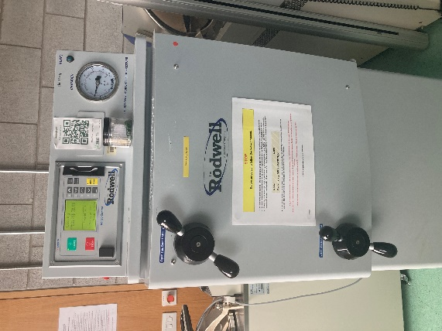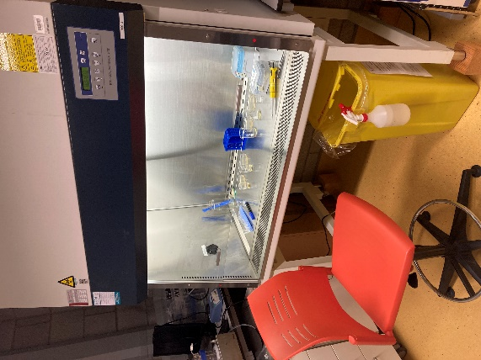

Safety cabinet of UL

Autoclave of UL

1: Pacemaker recycling: A notion whose time has come – World Journal of Cardiology – 2017

# My research project

As I said previously, the project is divided into several parts. It started with the definition of the project, which deals with the deadlines, the expectations of John and my colleagues work.

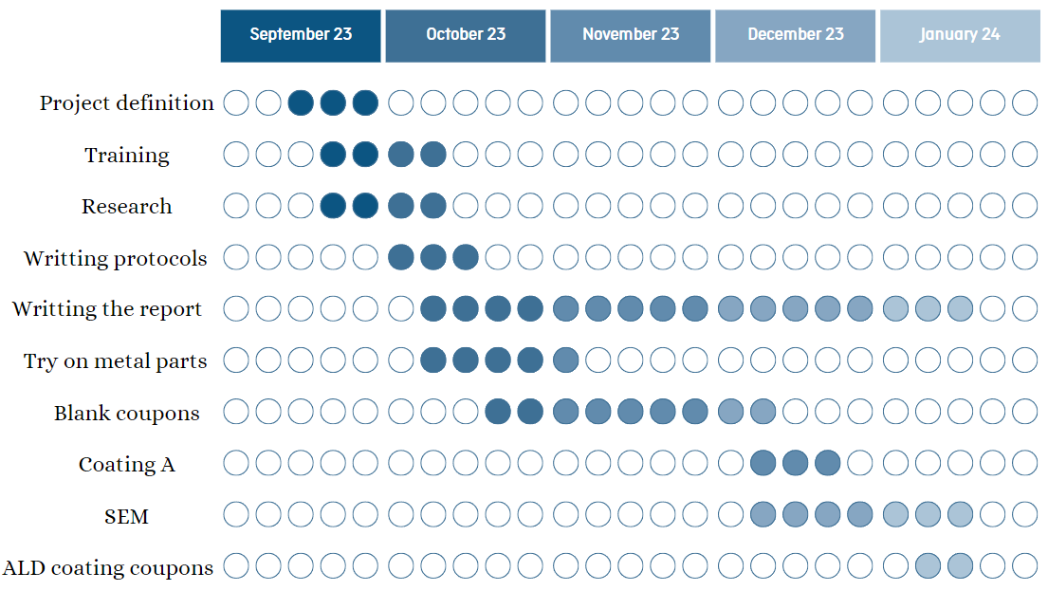

Figure 1 : Gantt chart of the project

## Project description

The main purpose of my mission is to sterilize coupons in the University, in order to check the effects of sterilization.

To carry out this project, I will receive several coupons made of different materials: titanium dioxide, nitinol (nickel and titanium alloy), stainless steel and copper. Each coupon will have the same coating on it. The area between the coating and the material is called the attachment.

I also have access to various sterilization methods as autoclave, alcohol and UV here at UL.

The first question asked is “What are the sterilization effects on attachment?” In order to answer that, I will use SEM (Scanning Electron Microscopy), FTIR (Fourier Transform Infrared) spectroscopy and mechanical tests, and compare them to those realized before sterilization.

Then, the second question is “Is it still anti-microbial?” In other words, is the sterilization effective or not? Here, we will carry out microbial tests.

To summarize, I will have to try all the sterilization methods with all the different materials and look at the side effects.

This project is born to help surgeons know what to do if a pacemaker is contaminated. Different aspects are highlighted: what is the easy and efficient way to sterilize a pacemaker, what a surgeon can do when he is in the OR and can a single-use device be sterilized again?

## Literature Research

### Sterilization methods used in hospitals

The first step was to look at methods generally used in hospitals in order to sterilize surgery tools, cloths, liquids or devices.

The first main sterilization process used is the autoclave. This is a machine which employs steam under pressure to kill bacteria. Various kinds of technologies exist, some using water drops or even gravity displacement. Four parameters are at utmost importance: temperature, pressure, exposure time and steam quality. The moist heat destroys microorganisms by irreversible coagulation and denaturation of enzymes and structural proteins.

The second method is the use of Ethylene Oxide (ETO). In fact, this colorless and flammable gas is utilized in hospitals, but the time cycle is long because of the aeration time which can last between 8 and 12 hours. Nevertheless, it can sterilize heat- or moisture-sensitive medical equipment without any deleterious effects. The microbial activity of ETO is the result of the alkylation of protein, DNA and RNA.

The third procedure for sterilization is ionizing radiation. There are two types of radiation: cobalt-60 gamma rays or beta rays from an electron accelerator. This method uses low temperature, which can sterilize items that cannot go to the autoclave. This is considered ionizing because the ray energy transforms atoms into ions and destroys the internal structure of the core.

To summarize, the main sterilization processes are autoclaving, ETO and radiation. Those three methods are complementary and allow hospitals to assure the sterilization of all the medical items.

At UL, we have an autoclave, alcohol and UV from the safety cabinet. Knowing that, we can try to mimic hospitals procedures with the same sterilization methods.

### Side effects of re-sterilization

The second step of my research was to check the side effects of the re-sterilization in general. I have read several articles about a second sterilization on surgical suture sets, transponders or even on meshes used for hernia surgery. Those items were made of stainless steel, gold, a platinum-iridium alloy and polypropylene. The methods used were autoclave, ETO and hydrogen peroxide.

Each article mentioned that no side effects were observed.

### How to sterilized / re-sterilized a pacemaker (which is a single-used device)

Single-use devices (SUD) should only be used on an individual patient during one procedure, and then be discarded. An SUD should not be reprocessed and used again. However, the European Commission wrote an article on the safety of reprocessing SUDs. This is based on the Spaulding Classification which states what should be done depending on the device. See the infographic below:

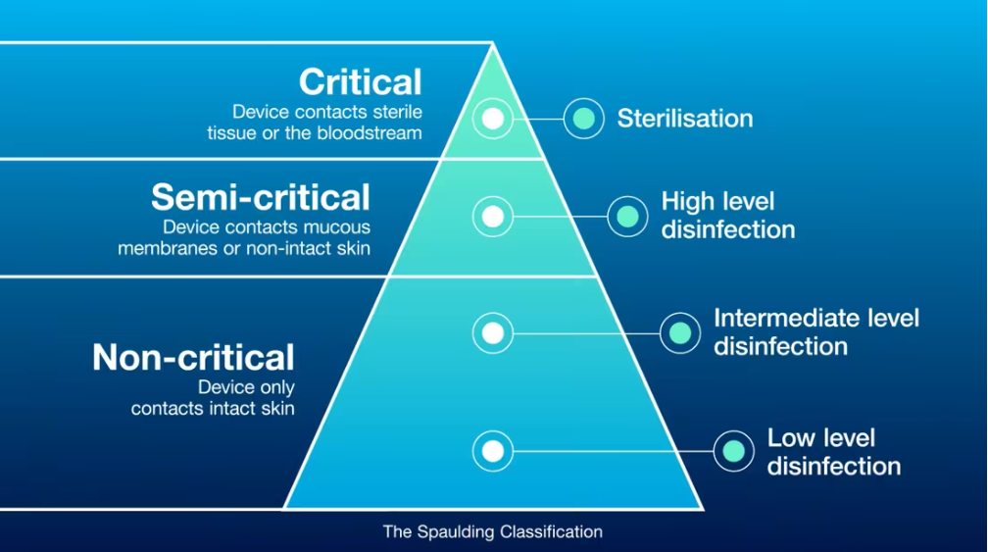

Figure 2 : Spaulding classification

A pacemaker, which is a cardiac implantable device, should be sterilized before re-using.

The article mentions the steps to re-use an SUD:

**Cleaning**: using an automated washer-disinfector or manually   
WARNING: The mechanical, thermal and chemical impact may influence the material properties and the construction of the device

**Disinfection**: performed by a chemical or thermal process with a disinfectant, then dry  
For thermostable material: water at 80-96°C for less than 10 minutes  
For thermolabile material: aqueous chemical disinfectant with low temperature

**Assembly, inspection and packaging**: device is reassembled (if applicable), then check on the device to confirm the proper functionality and then package depending on the sterilization process

**Sterilization**: high temperature, gas and radiation sterilization

High temperature: reliable, easy to control for hollow and porous items, liquids, only for thermostable materials

Gas: Alkylating agent like ethylene oxide for a good penetration; oxidizing gases like hydrogen peroxide which doesn’t leave toxic substance after use

Radiation: gamma or beta rays

A protocol of the resterilization of Cardiac Implantable Electronic Devices (CIED) is available for the surgeons (Annex 1).

A few Mexican doctors used previous studies about the reprocessing of CIEDs and tried to resterilize pacemakers for Mexicans that cannot afford new ones. They checked that the device functions, cleaned it with enzymatic soap and autoclaved it for 38 minutes. Then, they rechecked the functionality, and it was a success.

### Material

For this project, the received coupons are made of titanium dioxide, nitinol, stainless steel and copper. I had to be sure what sterilization method can be used for these materials.

* TiO2 (titanium dioxide) is heat-resistant and light-resistant and has excellent corrosion resistance

OK for autoclave and UV

* Nitinol (nickel titanium) has an excellent corrosion resistance and is heat-resistant

It returns to its original shape under high temperature

OK for autoclave and UV

* Cu (copper) has high corrosion resistance and is heat-resistant  
  Cu is also known to be bacterial resistant

OK for autoclave and UV

* Stainless steel has high corrosion resistance and is heat-resistant

OK for autoclave and UV

## Methods

### Protocols

The first step was to write down protocols for the three methods of sterilization.

The process is quiet similar for each one. However, you have to adjust some parameters, such as the exposure time and the packaging. Those depend on the methods used, because autoclave is based on heat-moisture sterilization and not UV.

The first step is to clean with water, then disinfect using 70% ethanol. If applicable, wrap the load, sterilize it and then store it.

In the protocols, you also have to think about how to make sure that the load is properly sterilized. For this topic, we had training on cell culture using broth and agar media. What you can do is spread bacteria out on the load or in the broth and incubate it. After a day, check the presence of bacteria and sterilize it. Once you have done that, you have to incubate it for a second time and then check again if there is any sign of bacteria presence.

### Training with metal parts

Before starting the sterilization of the coupons, my manager gave me metal parts with which I tested my protocols and improved them.

First, I decided to try the protocol with the autoclave sterilization.

The first step of that protocol is to prepare the media with 5mL of broth and 20µL of bacterial cells in a test tube. Then, add the metal part and incubate it in the shaking incubator.

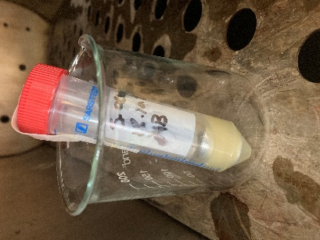Wait for 24 hours to let the bacteria grow. After that, put a drop of the broth in an agar plate, spread it out and incubate. This step is important because you will check the presence of bacteria before the sterilization. After that, I placed the load in the autoclave and started the cycle. The parameters are 15 minutes in 121°C, which is enough to kill every form of microorganism. Once this is done, I incubated the test tube a second time in the shaking incubator. I waited for one day to let the bacteria possibly develop themselves. Then, I repeated the step with the agar plate in another one, and incubate it.

After a while, we compared the two agar plates, before and after the sterilization. If some white dots appear, that means bacteria colonies grew. If not, then the poured broth is sterile.

You will find the full protocol in Annex 2.

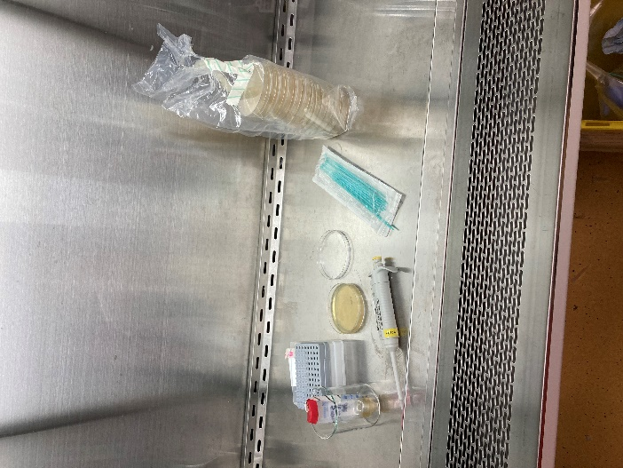

Bacterial culture

The following graph shows all the steps done.

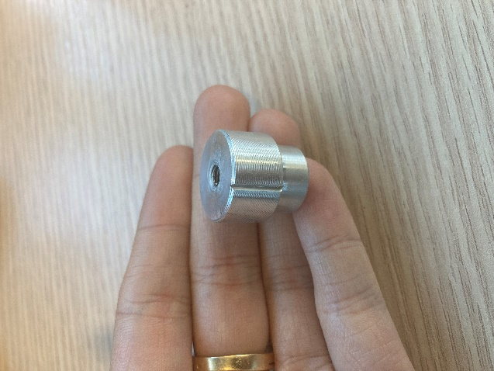

Metal part

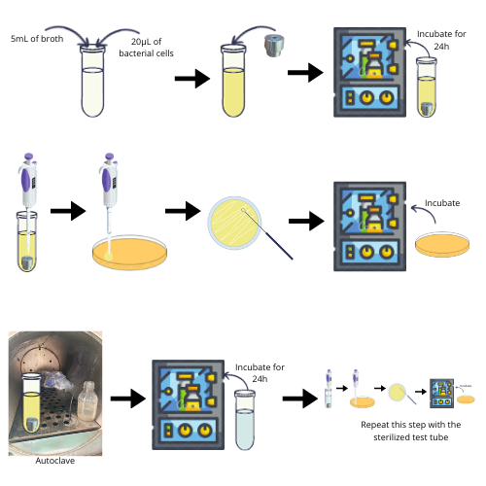

Figure 3 : Graphic of the autoclave protocol

The results were positive after 3 days of incubation, as the agar plate before sterilization was full of bacteria colonies, while the one done after the autoclave did not have any sign of microorganisms.

See the pictures below:

The second experiment was to sterilize the metal part with UV.

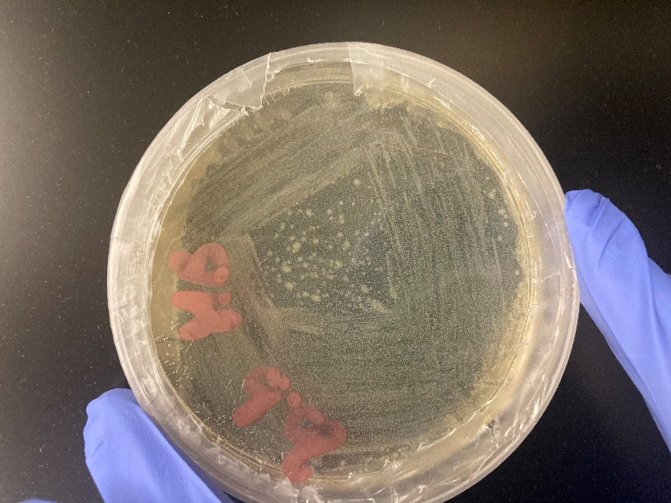

After autoclaving

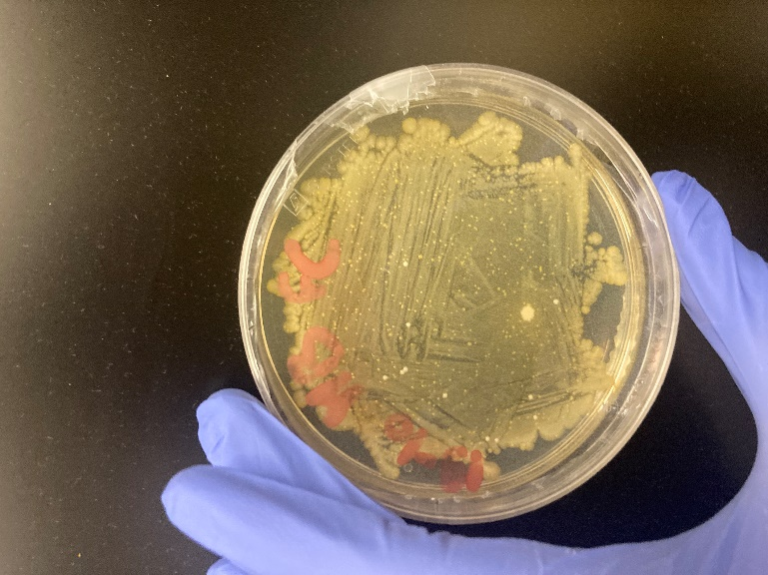

Before autoclaving

For this, I needed the fumehood from the lab for its UV light. For a good sterilization to kill every form of microorganism, the wavelength should be between 200 and 280nm. The radiation of the UV lamp in our cell culture hood is 254nm, so it should sterilize the load well.

The protocol is similar to the autoclave one, but the only thing that changes is the sterilization part. Instead of autoclaving, I put the test tube under UV for 20 minutes.

The UV protocol is in Annex 3.

Due to a contamination in the microlab, I had to stop the test before the end. In consequence, I don’t have any results for this experiment.

After the contamination, I received coupons for my project. So I decided to start the sterilization of those.

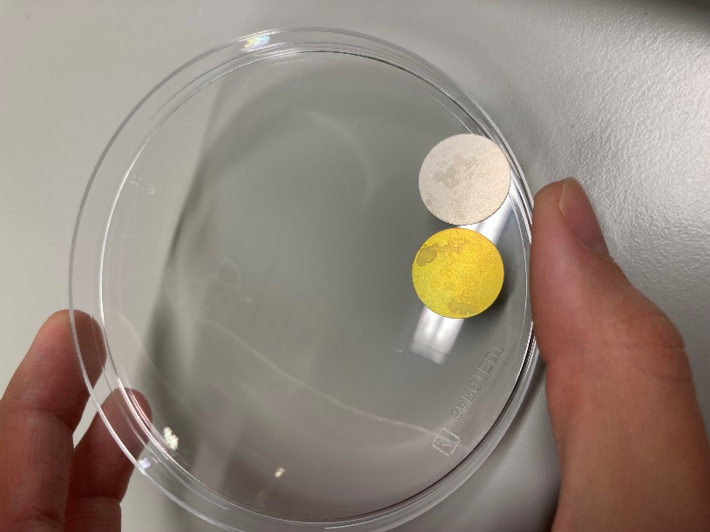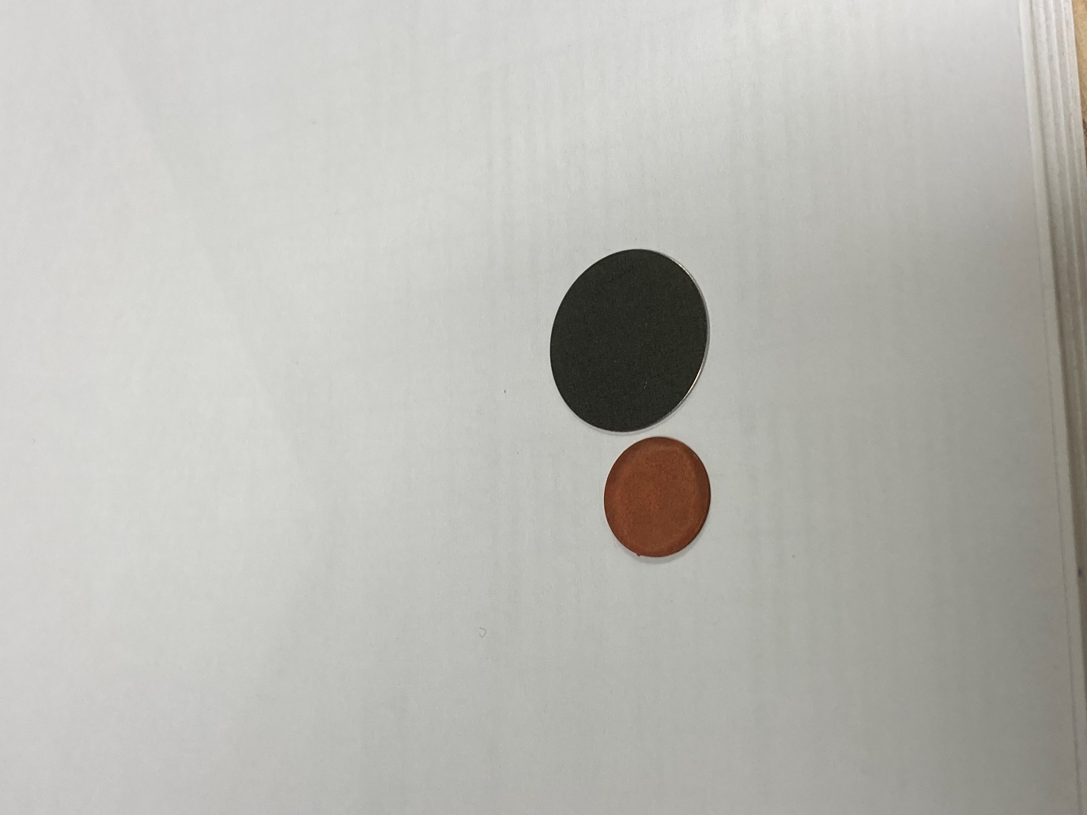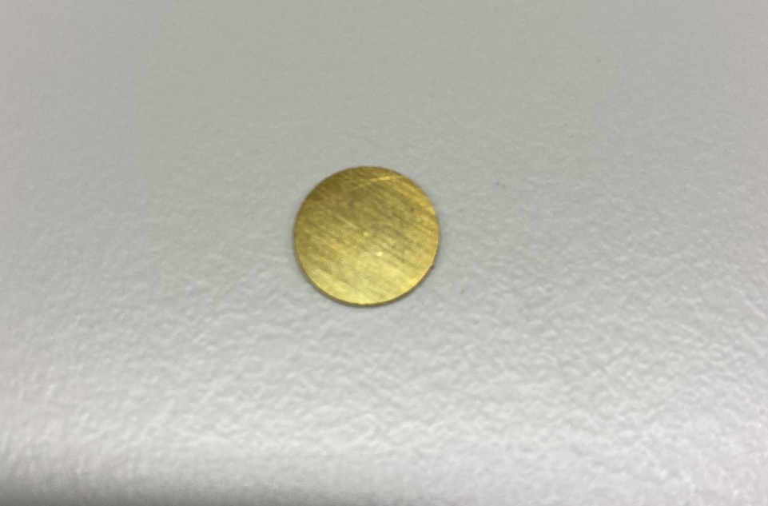

Copper and Titanium blank coupons

Copper ALD coated coupon

Titanium ALD coated and blank coupons

### Sterilization of coupons - Autoclave

For this project, I received titanium (Ti) and copper (Cu) coupons, with and without coating.

With those, I will test 2 methods of sterilization: autoclave and UV.

You will find the summary of all the experiments in Annex 9 and 10.

First, I started with blank coupons, so uncoated ones, in order to check if my protocols properly functioned.

I decided to use the autoclave at the first place.

The protocol is slightly different, after the disinfection with Ethanol, I put the coupon on a test tube with broth and bacteria, incubate for 2 hours and then wash the coupons with distilled water and put it in another broth. After that, I autoclave it with the same parameters (15 minutes at 121°C). Then, I spread a drop of the broth in an agar plate and check the day after if there is any bacteria colony.

#### Titanium coupons

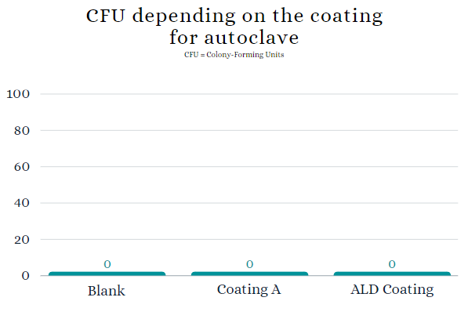

Figure 4 : Graph of the CFU on titanium coupons by autoclave

This graph shows that the sterilization by autoclave perfectly works for titanium coupons, blank or coated.

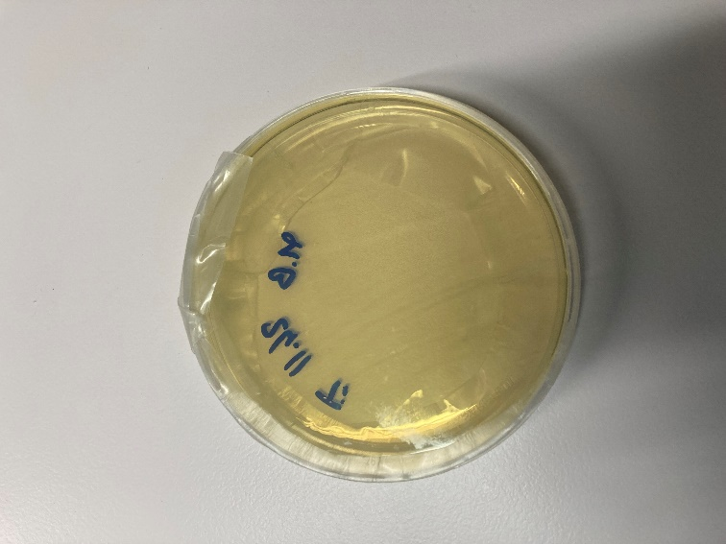

Blank coupon

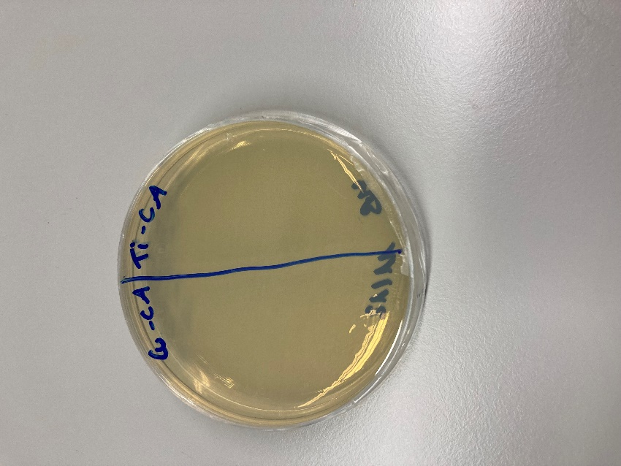

Coated A coupon

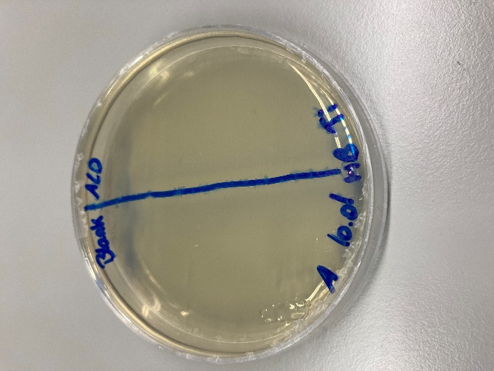

Coated ALD coupon

#### Copper coupons

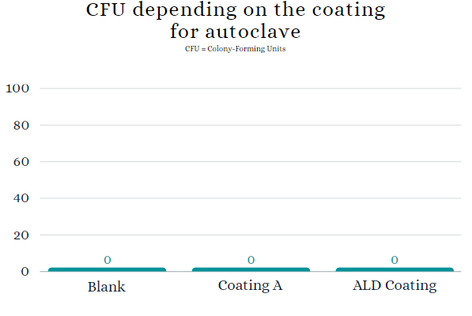

Figure 5 : Graph of the CFU on copper coupons by autoclave

This graph shows that the sterilization by autoclave perfectly works for copper coupons, blank or coated.

Coated A coupon

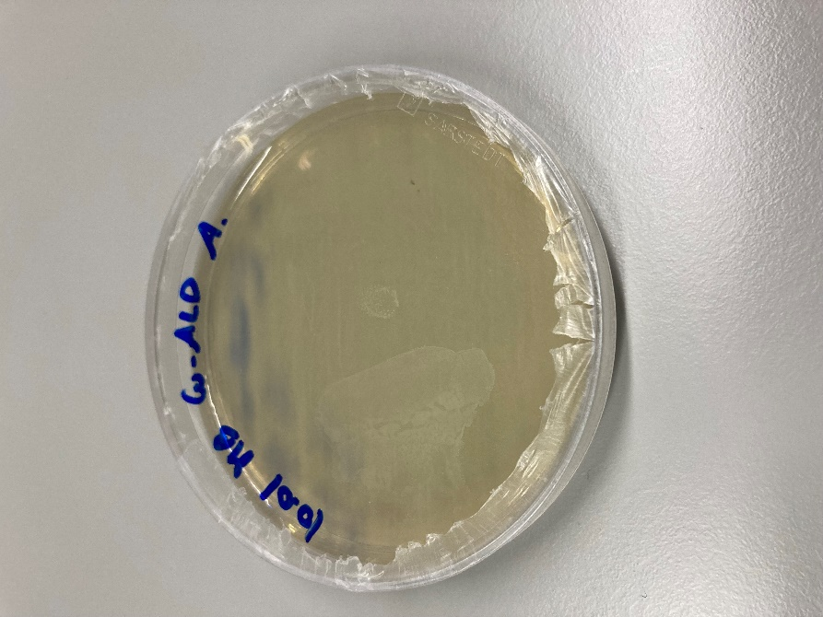

ALD coated coupon

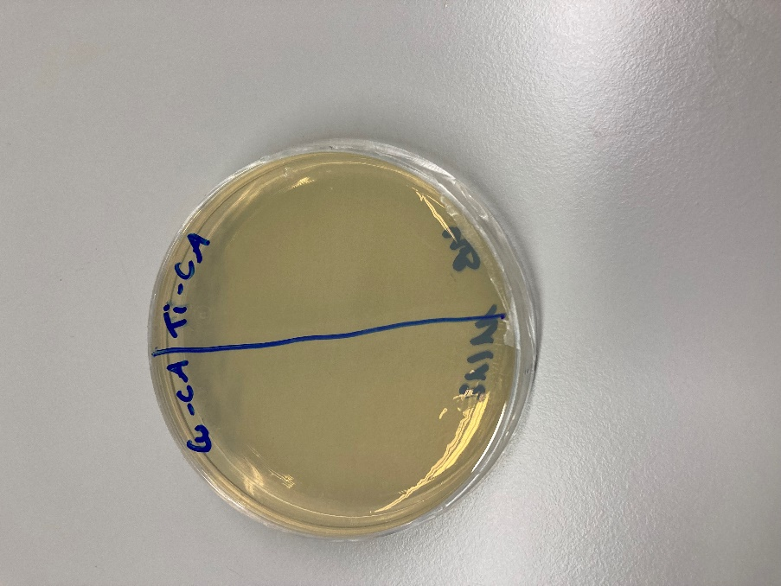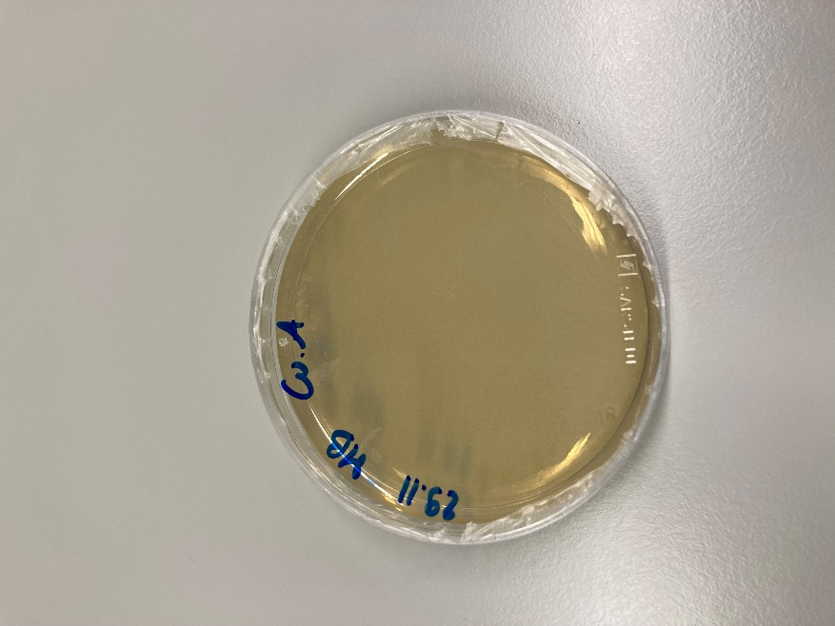

Blank coupon

### Sterilization of coupons - UV

After the success of the autoclave, I decided to try the protocol using the UV of the safety cabinet.

For this one, the protocol is to disinfect the coupon, put it on the broth with bacteria, incubate for 2 hours. Then, as the UV sterilizes surfaces and doesn’t go throw the item, I put the coupon on a plate without broth. I let it for 20 minutes, add new broth and wait for the broth to permeate the coupon. After that, I plate the broth and wait 24 hours to see the result.

#### Titanium coupons

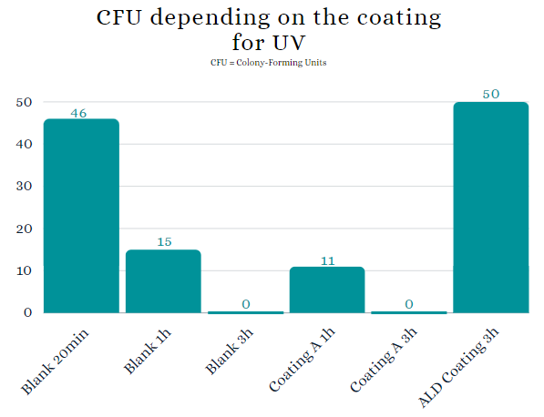

Figure 6 : Graph of the CFU on titanium coupons by UV

For the sterilization by UV, one of the parameter is very important: the exposure time.

Indeed, depending on the material and the coating, the timing needed to properly sterilize is not the same.

For titanium, 3 hours of UV is essential for the blank coupon and for the coating A.

However, the ALD coated coupons cannot be sterilized by UV.

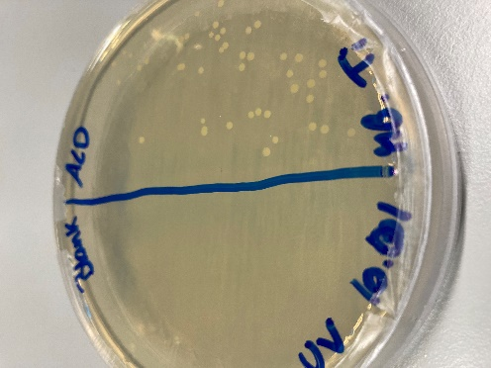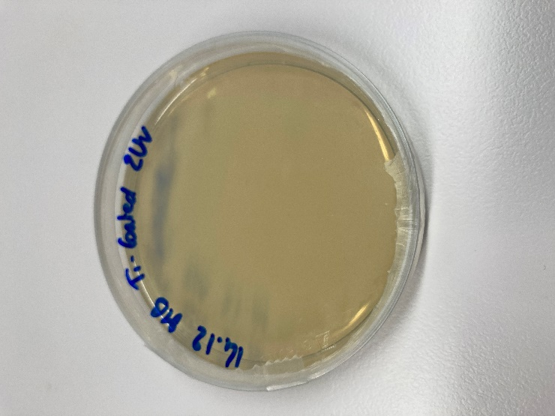

Coated A 3h

Blank 3h

ALD coated 3h

#### Copper coupons

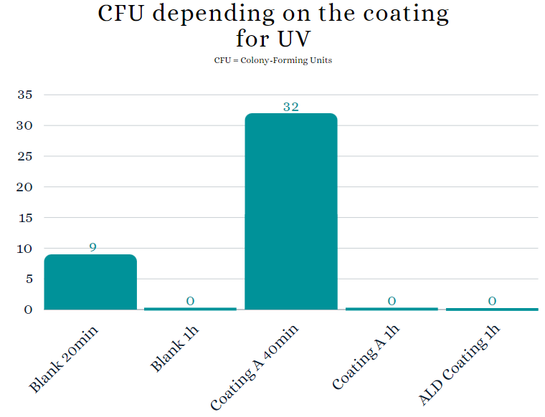

Figure 7 : Graph of the CFU on copper coupons by UV

Regarding copper, 1 hour is needed to succeed the sterilization.

It worked for blank, coated A and ALD coated coupons.

We can say that cooper is a better material, thanks to its natural anti-bacterial resistance property.

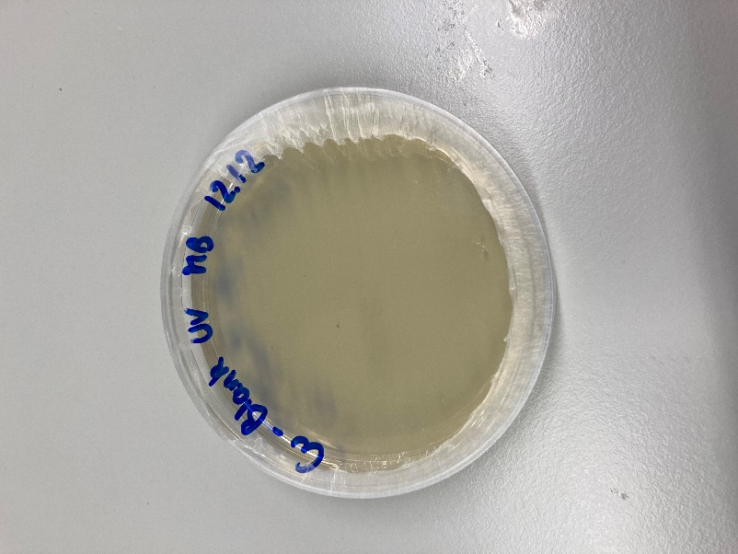

Copper blank coupon 1h

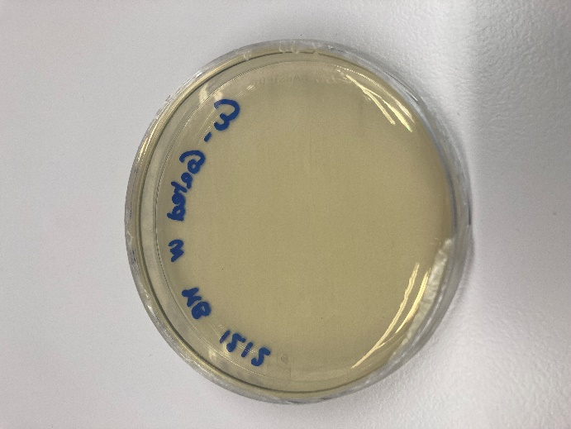

Copper coated A coupon 1h

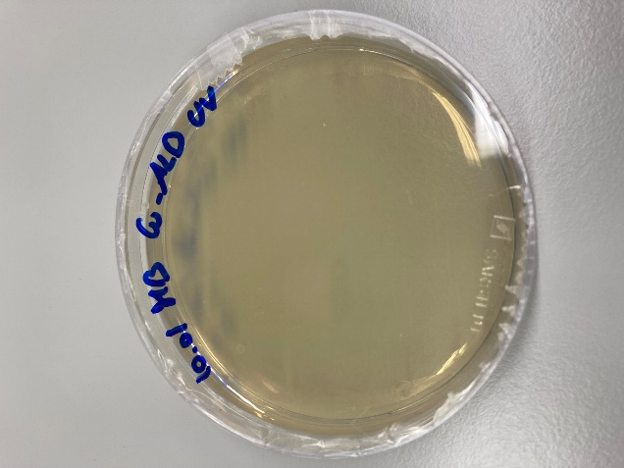

Copper ALD coated coupon 1h

### SEM method

With the previous experiments, I answered the question “is the sterilization effective or not?”.

The second part of the project was to see if the sterilization by autoclave or UV do have side effects on the material.

In order to answer that, I used a SEM (Scanning Electron Microscope). In fact, this device uses electrons instead of light to have a better look on the surface of the material.

We started to observe titanium and copper blank coupons. Here are a few pictures we took:

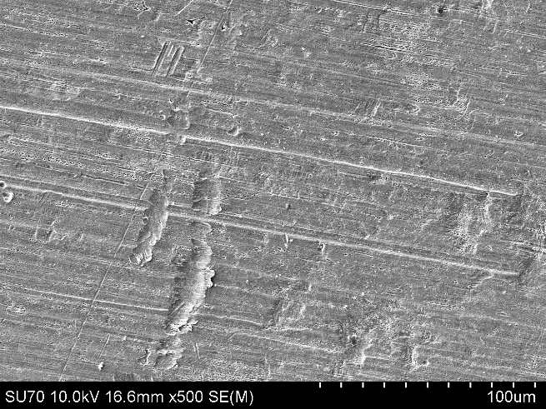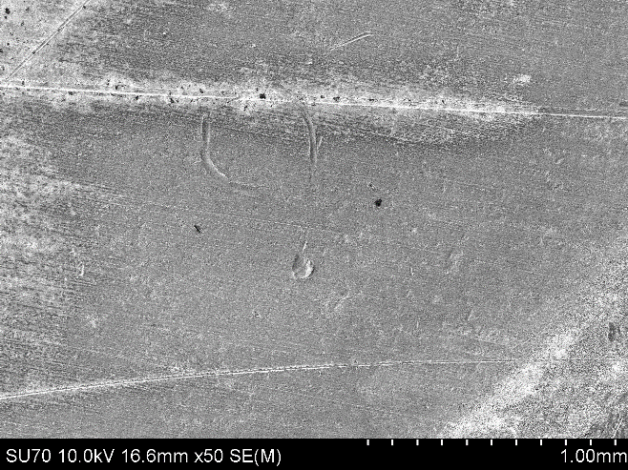

Copper blank coupon

Copper blank coupon

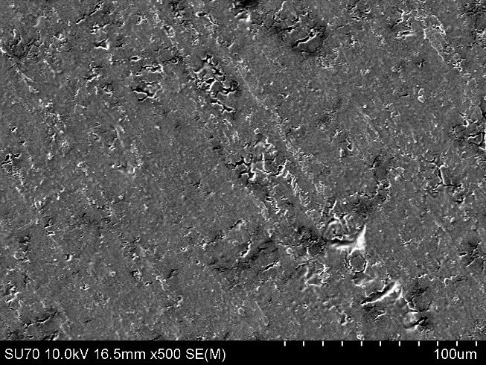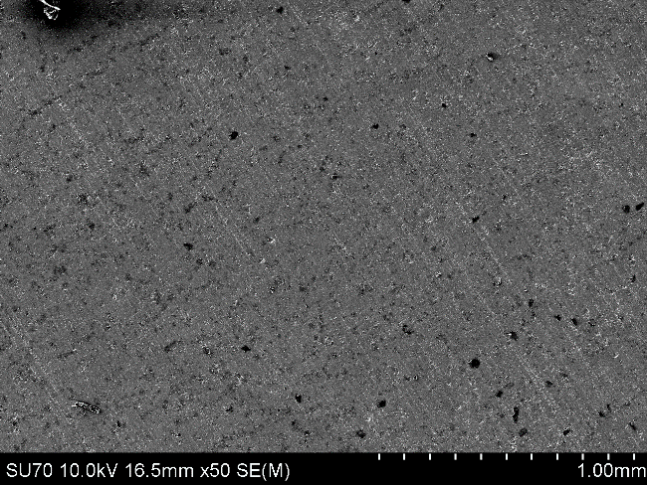

Titanium blank coupon

Titanium blank coupon

# Conclusion

# Glossary

**Agar media**: A base for bacterial culture media. Used to grow microorganisms and counting.

**Agar plate**: A petri dish filled with agar media.

**Alkylation**: The alkylation is the replacement of a hydrogen atom with an alkyl group, which prevents normal cellular metabolism.

**Autoclave**: Metal container with a hermetic closure, used to sterilize load with high temperature and high pressure.

**Bacteria**: Microbe with a simple cell structure. Their genetic information are contained in a single loop of DNA.

**Bradyarrhythmia**: An abnormally slow resting heart rate. It can be treated by the implanting a pacemaker.

**Broth**: A liquid medium containing nutrients for the culture of bacteria.

**Cell culture**: method used to cultivate and grow a large amount of cells.

**Denaturation**: Deterioration of the protein molecular structure, that is now not functional.

**Disinfect**: Thermal or chemical destruction of pathogenic and other types of microorganisms. Disinfection is less lethal than sterilization because it destroys most recognized pathogenic microorganisms but not necessarily all microbial forms.

**High-level disinfection**: Agent capable of killing bacteria spores when used with sufficient concentration under suitable conditions. It therefore is expected to kill all other microorganisms.

**Intermediate level disinfection**: Agent that destroys all vegetative bacteria, including tubercle bacilli, lipid and some no lipid viruses, and fungi, but not bacterial spores.

**Load**: item, batch

**Low-level disinfection**: Agent that destroys all vegetative bacteria (except tubercle bacilli), lipid viruses, some no lipid viruses, and some fungi, but not bacterial spores.

**Microorganism**: animals or plants of microscopic size. As used in health-care, generally refers to bacteria, fungi, viruses and bacteria spore.

**Reprocess**: Method to ensure proper disinfection or sterilization. It can include cleaning, disinfection, inspection, wrapping, sterilization, checking and storing.

**Thermolabile**: Material, which is unstable when heated, readily destroyed or deactivated by heat.

**Thermostable**: Material, which is stable when heated, not readily destroyed or deactivated by heat.

**Sterilize**: Validated process used to render a product free of all forms of viable microorganisms.

# Annex

## Annex 1: Reprocessing of CIED

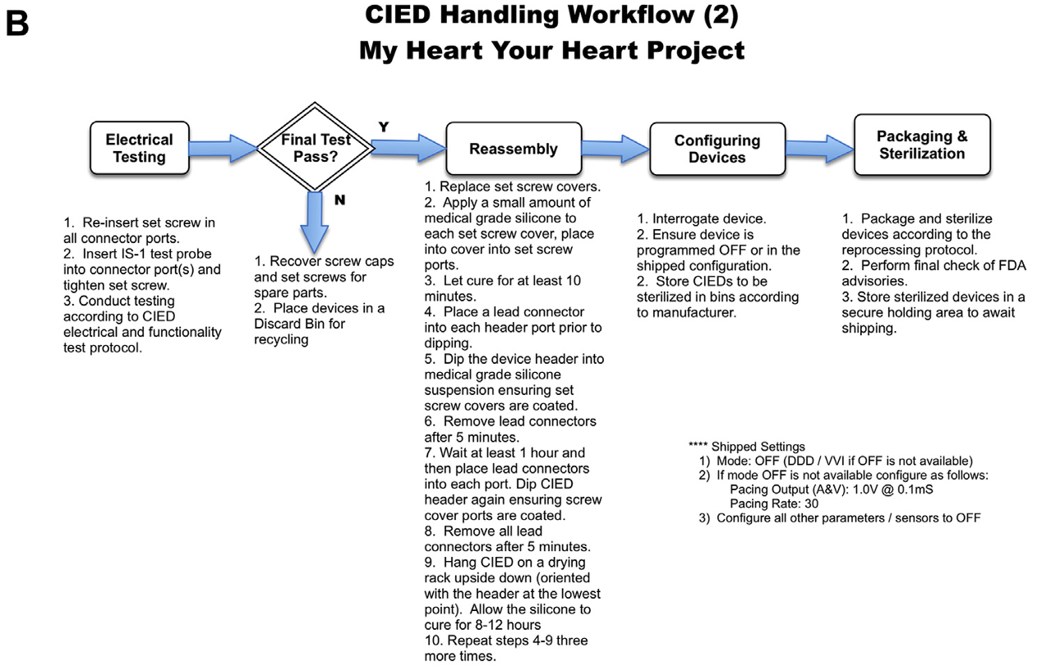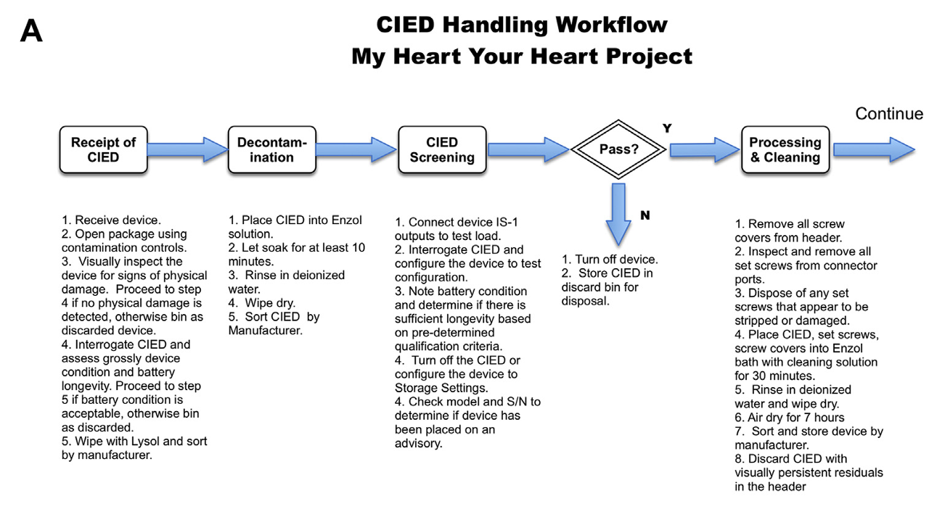

## Annex 2: Sterilization protocol of metal part by autoclave

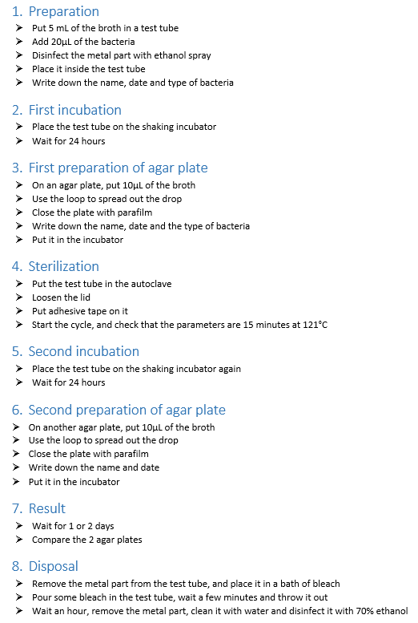

## Annex 3: Sterilization protocol for metal part by UV

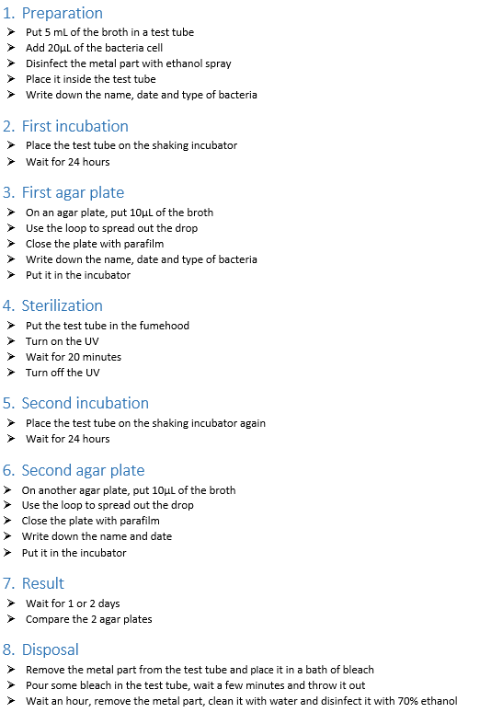

## Annex 4: Sterilization protocol for coupons by autoclave

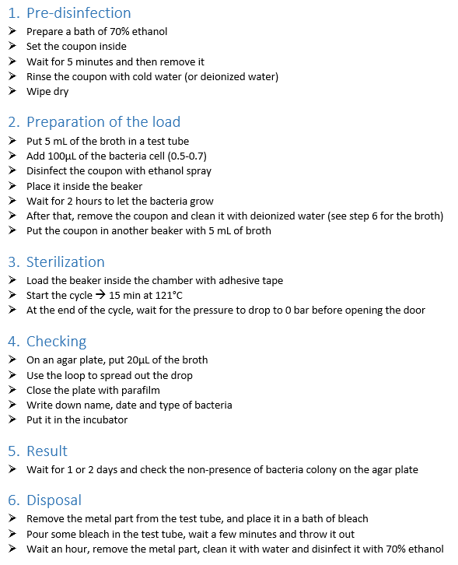

## Annex 5: Sterilization protocol n°1 for coupons by UV

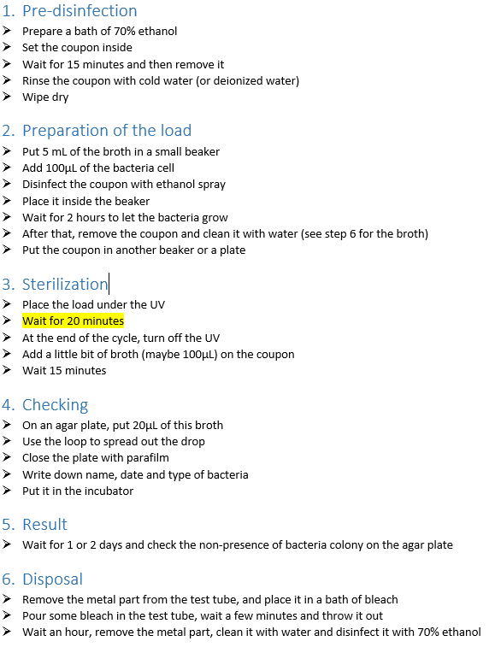

## Annex 6: Sterilization protocol n°2 for coupons by UV

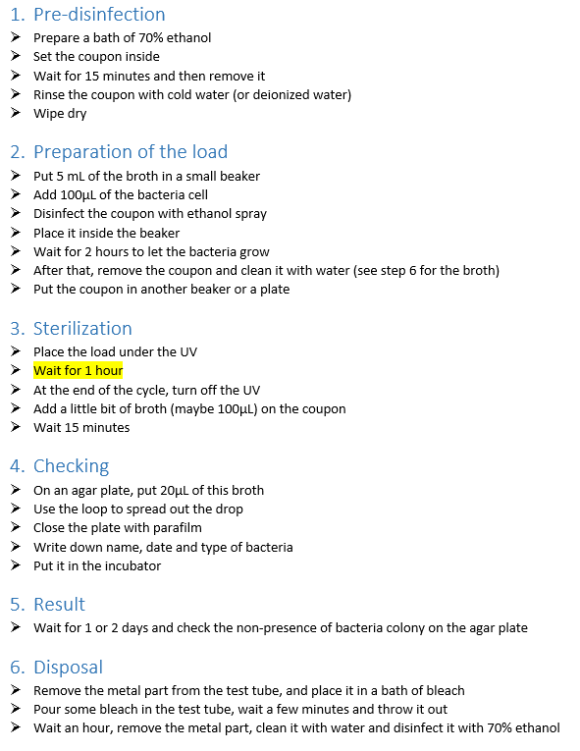

## Annex 7: Sterilization protocol n°3 for coupons by UV

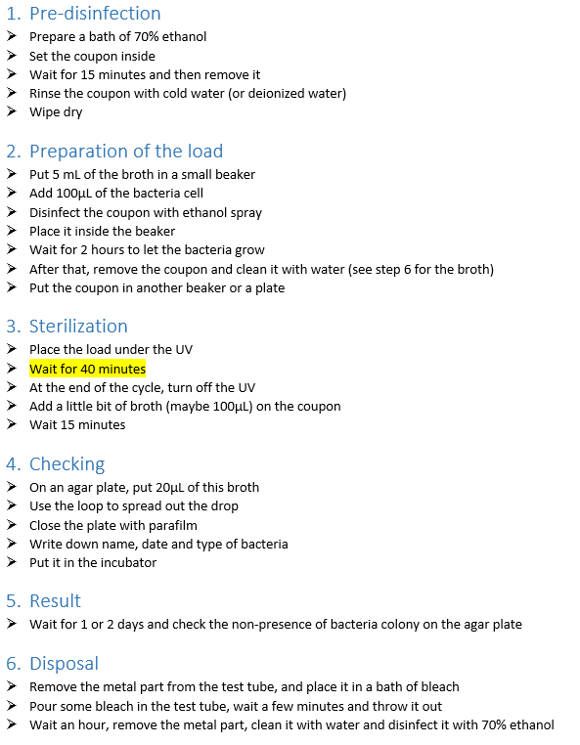

## Annex 8: Sterilization protocol n°4 for coupons by UV

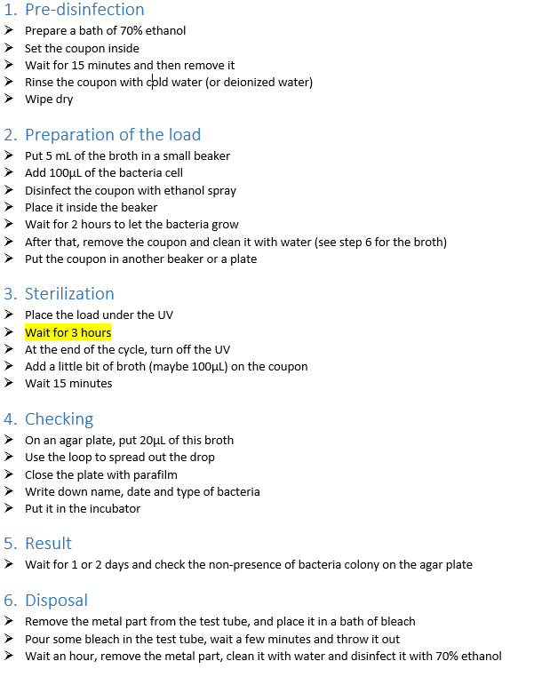

## Annex 9: Summary of all the autoclave experiments

25

## Annex 10: Summary of all the UV experiment

